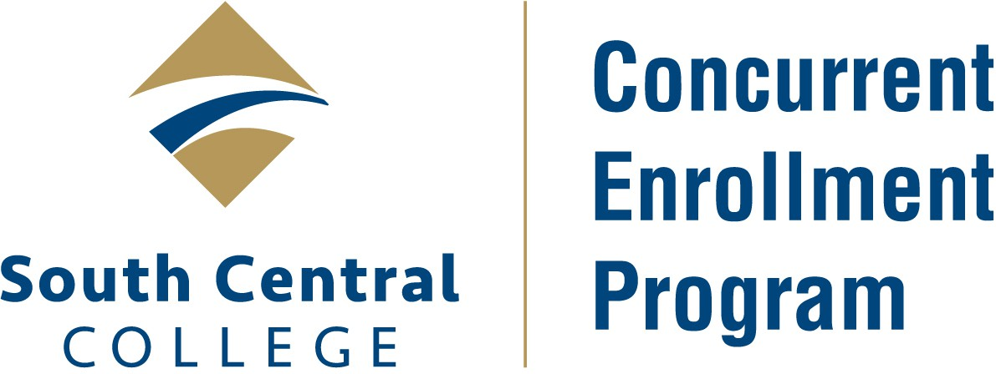

Step by Step Guide to the Concurrent Enrollment Program Online Application Process

For high school students applying to take Concurrent Enrollment courses in their high school

Application Link: https://eservices.minnstate.edu/adm/public/studentWelcome?campusId=274&appType=underGrad
(Can be also be found on the www.southcentral.edu page using the “Apply” link)

*If you already have a StarID from another Minnesota State institution, select “Login”. You will log into your account using that StarID and password. Skip down to the *Application Process below and follow those steps. Some of your application information will populate from your Minnesota State system account.

**If you have not applied to another Minnesota State institution, select “Create StarID” and follow these steps:

**How to Create your StarID:
- Enter First and Last Name
- Enter and re-enter an Email Address – (this needs to be a personal email address (not a family email) that you will have access to immediately)
- Enter and re-enter a Password
- Check the Acknowledgement box (then select “Create my StarID”)
- A confirmation message will appear indicating your StarID was successfully created
- Check your email for your StarID and a link to return to the application
- Note: Save your StarID and password in a secure location
- Select “Login” and use your StarID and password to continue your application

*Application Process – (fields with asterisks are required)
Personal
  - Fill out Legal Name and Email Address (then select “Next”)
  - Fill out Social Security Number (SSN) (if known) and Date of Birth (then select “Next”)
  - Fill out Veteran Status (then select “Next”)
  - Fill out Parent Education (then select “Continue to Citizenship”)

Citizenship
  - Fill out Citizenship (then select “Continue to Contact”)

Contact
  - Fill out Residency (then select “Next”)
  - Fill out Permanent Address (then select “Next”)
  - Fill out Phone Number (then select “Continue to Education”)

Education
  - Under High School Information – select “Yes” you are currently a High School Student (then select “Next”)
  - Fill out High School Attended (use June as the month and your graduation year then select “Next”)
  - Skip Colleges / Universities Attended and click on “Continue to Confidential”

Confidential
  - Fill out Demographic Information (then select “Continue to Major”)

Major
- Under Application Term – select the semester in which you will take your first Concurrent Enrollment course from SCC (then select “Next”). If the term is not listed, select a future term and SCC will update as needed
  - Under Application Type – select “Post Secondary Enrollment Option (PSEO) Student” (then select “Next”)
  - Under Educational Intent – select “Complete courses, but not a degree.”
  - And click “Part Time Student” (then select “Next”)
  - Under Academic Program – click on “Next”
- Under Application Campus – select “SCC Concurrent Enrollment” (then select “Next”)
  - Under Application Information - select “No” you haven’t attended South Central College before (then select “Continue to Additional”)

Additional
  - You may skip Activities & Sports and click on “Continue to Review”

Application Review
  - Review all provided information and make sure it is listed correctly. If you need to make changes, you can select the green box associated with that area on the top of the screen. Once all information is verified, select “Continue to Submit Application”

Applications
  - A box that says “South Central College” will appear on the screen. Check the box next to the SCC application and then enter your StarID password in the box marked “*Verify StarID Password ”
  - Click “Submit Selected Application(s)”
  - From here you will be brought to the Application Status page where you can see the status of the application listed as either “Pending” or “In Progress” and the date it was submitted

Your SCC application is now complete. This does not mean that you are registered for a concurrent enrollment course, however. That is a separate process that will be done by the SCC Secondary Relations team – please watch your email for updates.

SCC Secondary Relations Office
Phone: 507-389-7494
Email: secondaryrelations@southcentral.edu

