SECTION 1: Student Information
Last Name First Name Student or STAR ID

SECTION 2: Family Information
In the table below, list the people your parent(s) will support between July 1, 2026 and June 30, 2027. Include:
- The student
- The parent or parents (including step-parents) of the household
- Your parents’ other children/stepchildren (even if they do not live with your parents) if your parent(s) provide more than half of their support and will continue to provide more than half of their support through June 30, 2027
- Other people, only if they now live with your parent and will receive more than half of their financial support from your parent and will continue to receive that financial support through June 30, 2027

If any of the people listed will be attending college at least half time (6 or more credits) in a degree, diploma or certificate program between July 1, 2026 and June 30, 2027, please list the name of the college they are attending
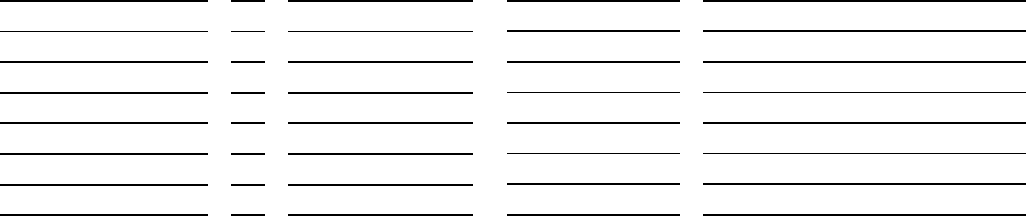
Name Age Relationship to Student College Program Level (PSEO, undergraduate, graduate)
South Central College Undergraduate
Student

SECTION 3: Signature
By signing this form, we certify that all the information reported on this form is complete and correct.
Student Signature* Date Parent Signature* Date

*We cannot accept a digitally typed signature. An ink signature is required.

RETURN BY EMAIL
financialaid@southcentral.edu

RETURN BY FAX
(507) 389-7419

RETURN BY MAIL - NORTH MANKATO CAMPUS
South Central College Financial Aid Office 1920 Lee Boulevard
North Mankato, MN 56003 Office Use: 0407, 0409, 0507, 0509

