Microsoft 365 Installation
Purpose | Scope
To instruct on installing Microsoft 365 from your SCC account | This applies to all SCC students and permanent SCC Employees

Log in and install
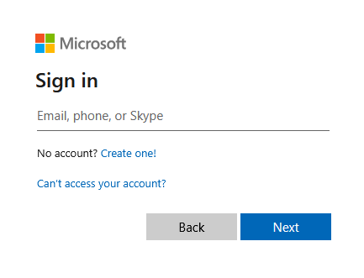
You may install Microsoft Office on up to 5 computers and 5 mobile devices. Your license will only be valid while you are currently enrolled in SCC courses or employed with the college. Please note that available applications differ between operating systems.

- Login to your Office 365 account at the following link: https://m365.cloud.microsoft/apps
  - Students log on with YourStarID@go.minnstate.edu
  - Employees log on with YourStarID@minnstate.edu

- After you have logged into your Office 365 account, click on the Waffle icon in the upper left and then More Apps
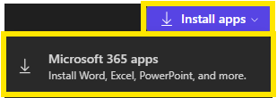
- Click on Install apps in the upper right, then click Microsoft 365 apps

- Once the new tab opens, click Install Office

- Save the download to your computer

- Open the download and run the installer program

- Sign in using your SCC Office 365 credentials when you launch the programs to license them

